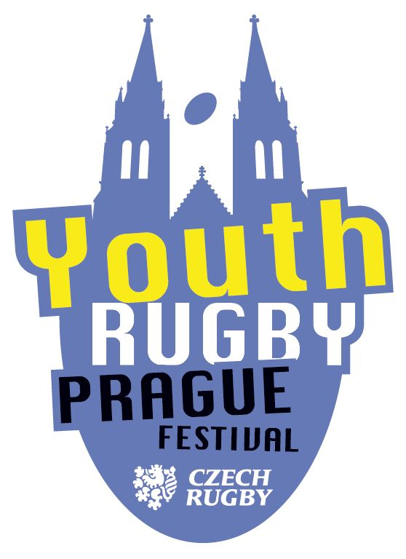 | P R A G U E Y O U T H  R U G B Y F E S T I V A L  U12

XXXV. PICO CUP / PYRF U12

COMPETITION SCHEDULE

Tournament organizer: Rugby Club Petrovice in cooperation with Prague Youth Rugby Festival

Main organizer: Jana Stupková, phone: 607 877 793, e-mail: jastupkova@gmail.com

Date and place of the tournament: Saturday, October 17, 2026, RK Petrovice stadium, Grammova 408/6, 109 00 - Prague 10
DUE TO THE CLOSURE OF EDISONOVA STREET, THERE IS A STRICT BAN ON ENTERING GRAMMOVA STREET, USE THE PARKING LOT AT THE DOPPLEROVA ELEMENTARY SCHOOL

Registered teams:
RG Heidelberg Orange (GER), RG Heidelberg Black (GER), Zagreb rugby union (CRO), Energa Ogniwo Sopot (POL), RC Gryf Rotmanka I (POL), RC Gryf Rotmanka II (POL), Rugby Olymp, RC Slavia Praha I, RC Slavia Praha II, RC Mountfield Říčany I, RC Mountfield Říčany II, RC Bystrc Orange, RC Bystrc Black, RC Praga Praha I, RC Praga Praha II, Rugby Babice, RK Petrovice I, RK Petrovice II, RC Tatra Smíchov I, RC Tatra Smíchov II, JIMI RC Vyškov, RC Sparta Praha, Rugby Academy Brno, RC North (association of clubs RC Griffins Jablonec and RC Liberec), RC Plzeň / Nýrsko (association of clubs RC Plzeň and RC Šumava Nýrsko), RC Kralupy n/Vlt., RC Dragon Brno, ARC Iuridica Chrášťany, Strong Girls & Boys.

Conditions of start: players boys and girls born in the period from 1.1.2015 to 31.12.2016 inclusive. Players of teams associated in Czechoslovakia must have a valid Czechoslovak player license on the date of the tournament. Team leaders will fill in the rosters of players in the Union Information System no later than October 16 at 12:00 p.m. They will then bring the same roster printed and signed by the head coach or team leader for registration before the tournament. The club affiliation of a player is not determined. Each team has its own separate roster. Clubs with two teams in the competition will make one roster in the IS, before the tournament they will mark in the roster which player plays for which team.

Entry fee: the entry fee for one team is set at CZK 1,750.

Tournament schedule:
8.00 a.m. opening of the complex
08.30 – 09.00 Tournament registration, coaches will submit signed rosters according to the above
09.00 - meeting of coaches at Háček closer to the clubhouse
09.30 - kick-off of the first matches
09.30 – 12.50 matches in qualifying groups
12.50 – 13.40 lunches
13.40 – 17.00 matches in the final groups
17.00 – finals and matches for 3rd place of the tournament
Around 5.30 p.m. announcement and closing ceremony of the tournament

Tournament Playing System:
The tournament is competitive
1st phase of the competition
The 29 teams are divided into six qualifying groups A-F, groups A-E have five teams and group F have four teams. In the groups, everyone plays each other once.
2nd phase of the competition
The top two teams from each qualifying group advance to the two CUP final groups of six teams each. In the final group CUP 1, teams from qualifying groups A, B and C play, in the final group CUP 2 teams from qualifying groups D, E and F.
The teams placed in the third and fourth places of the qualifying groups advance to the two final PLATE groups of six teams each. In the final group PLATE 1, the teams from qualifying groups A, B and C play, in the final group PLATE 2 the teams from qualifying groups D, E and F play.
In the final groups of the CUP and Plate, the teams play each other, with the exception that the mutual matches of the teams from the same qualifying group are no longer repeated and the result of these teams from the qualifying group is counted in the table.
The teams ranked fifth in qualifying groups A-E advance to the final group of the BOWL for the 25th to 29th place overall in the tournament. In this group, everyone plays against each other.
Final part
The winners of the final groups CUP 1 and CUP 2 play a match for the overall winner of the tournament.
The second-placed teams in the final groups of CUP 1 and CUP 2 play a match for the third place in the tournament.

Playing time:
In the qualifying and final groups, matches are played with a playing time of 1x 7 minutes.
In the final matches, matches with a playing time of 2x5 minutes are played.
Matches are not extended

To determine the ranking in the tournament:
The winner of the tournament is the winning team from the final match of the first of the final groups CUP 1 and CUP 2. In the event that the match ends in a draw, the winner is the team that has a better record in its final group. The losing team takes second place in the tournament.
The third place in the tournament is occupied by the winning team from the final match of the second of the final groups CUP 1 and CUP 2. In the event that the match ends in a draw, the third place is taken by the team that has a better record in its final group. The losing team occupies the fourth place in the tournament.
There is no play for the next placement and only the balances of the teams from their final group are compared. For example, the fifth place in the tournament is occupied by the third team of the final groups CUP 1 and CUP 2, which has a better record in its group, the one with a worse record occupies the 6th place. Other positions are compared in a similar way.
The order of the teams in 25th to 29th place is determined by the BOWL group table.

The determination of the order in the groups applies to both the qualifying and final groups:
Scoring the result of the match: win 3 points, draw 2 points, loss 1 point. In case of non-appearance
teams for the match, the score of 5:0 and 3 points counts for the entered team, the unentered team
score 0:5 and 0 points.
In the event of an equal number of points in the group, the following factors determine the placement in this order:
a) Greater difference between the achieved and received positions (smaller in the case of a negative number) in
group
b) if a) is identical, then a greater number of achieved positions in the group
c) if a) and b) are the same, then the result of the mutual match
d) if a) and b) and c) are identical, then a smaller number of players excluded in the tournament
e) if a) and b) i c) and d) are the same, then a larger number of players of the younger year (2016) written on the roster
(f) if (a) and (b) and (c) and (d) and (e) are the same, then the

Rules: "Modifications to the rules of rugby for youth, pupils and preparations March 2026" of April 1, 2026, category U12 autumn, with mills and cars.

Referee: Chief Referee Mr. Raymond Burnard

Technical and organizational requirements:
- Moravian teams will be assigned dressing rooms in the clubhouse.
- Tents will be available for teams from OPČ. If you want, you can bring your own tent and set it up in the area above the field, or at the very back behind the field 3.
- Parking – entry to Grammova Street will be prohibited except for supplies (supplying is not that I am taking players to a tournament!!), please use the adjacent parking lots, namely in Morseova Street – above Sokolovnou, or in Dopplerova Street – between schools, this parking lot is also suitable for buses. All these parking lots are free of charge
- Only referees, players, coaches, scorers, organizers are allowed to enter the playing area of the entire field. Please warn the players' parents to watch the match from the stands or from the adjacent areas of the field.

Sincerely,
Good luck to rugby!
Oto Petrášek – member of the organizing committee of PYRF / PICO CUP U12 – autumn 2026

PICO CUP WINNERS OVERVIEW
I.year 1991 – RC Tatra Smíchov
II.year 1992 – results have not been preserved
III.year 1993 – results have not been preserved
IV.year 1994 – RC Vyškov
V.year 1995 – RK Petrovice
VI.year 1996 – RK Petrovice
VII.year 1997 – RC Slavia Prague
VIII.year 1998 – the results have not been preserved
IX.year 1999 – results have not been preserved
X.year 2000 – results have not been preserved
XI.year 2001 – results have not been preserved
XII.year 2002 - results have not been preserved
XIII year 2003 - results have not been preserved
XIV.year 2004 – results have not been preserved
XV.year 2005 – RC Říčany
XVI.year 2006 – JIMI RC Vyškov
XVII.year 2007 – JIMI RC Vyškov
XVIII.year 2008 – RC Tatra Smíchov
XIX.year 2009 – RC Sparta Prague
XX.year 2010 – RC Říčany
XXI.year 2011 – RC Říčany
XXII.year 2012 – RC Říčany B
XXIII.year 2013 – RC Říčany B
XXIV.year 2014 – RC Říčany A
XXV.year 2015 – RC Říčany
XXVI.year 2016 – RC Mountfield Říčany A
XXVII.year 2017 – RC Mountfield Říčany A
XXVIII.year 2018 – RC Tatra Smíchov A
XXIX.year 2019 – RK Petrovice
In 2020, the tournament was not held due to the global COVID 19 pandemic
XXX.year 2021 – RC Mountfield Říčany
XXXI 2022 – RC Tatra Smíchov I
XXXII.year 2023 – RC Mountfield Říčany I
XXXIII.year 2024 – RC Mounfield Říčany A
XXXIV.year 2025 – RC Tatra Smíchov I
XXXV year 2026 - ?????

