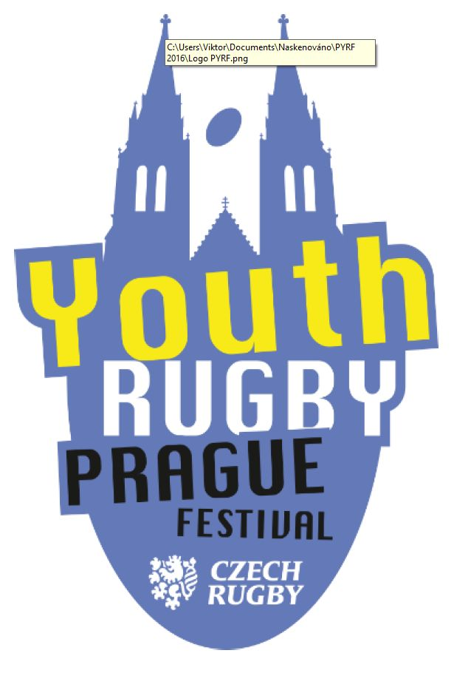 | PRAGUE YOUTH RUGBY FESTIVAL 2026  AUTUMN EDITION  REGISTRATION FORM  OCTOBER 16 - OCTOBER 18, 2026

Name of the club: ……………………………………….………………...………………….

Address of the club: ……………………………………….………………...………………….

Responsible contact person name:…………………………………….………………...…………………..

Contact phone number: ……………………………………….………………...………………….

Contact e-mail: ……………………………………….………………...………………….

We will participate with following teams:
Category | U18 - 7´s | U16 - 7´s | U14 | U12 | U10 | U 8
Category | GIRLS | GIRLS
Number of teams:
U18 – 7s girls UPON REQUEST in autumn 2026 PYRF edition – PLEASE CHECK with us FIRST !

Preferred accomodation (choose from the list) is hotel: .………………….…………….……………..

Accomodation with breakfast ONLY ………….………………… (yes / no)
or with halfboard = breakfast and dinner: ….………………….. (yes / no)

Number of children: ……………………… Number of adults: ……………….………………..

TOTAL NUMBER OF PARTICIPANTS: ………………………………………………………

DATE OF ARRIVAL: ……………..…., 2026 DATE OF DEPARTURE: ………………., 2026

ROOMING REQUEST – PLEASE SPECIFY HOW MANY ROOMS DO YOU REQUEST:
Single rooms: ……………. Triple rooms: …………………. Rooms for 6 persons: ………..
Double or twin rooms: ……... Quadruple rooms: ……………. Dorm rooms: ………………….
Twin rooms: ……………… Rooms for 5 persons: ………. …………………………….

☐ We would like to receive an offer for sightseeings, trips, excursions.

☐ BUS package 1 (airport - hotel - airport and hotel - rugby pitch - hotel on match day)

☐ BUS package 2 (hotel - rugby pitch - hotel on match day)

Any special needs or demands concerning your stay:

………………………………………………………………………………………………………………………

………………………………………………………………………………………………………………………

………………………………………………………………………………………………………………………

Fill in the application and send to e-mail address pyrf@estec.cz before September 10, 2026!

