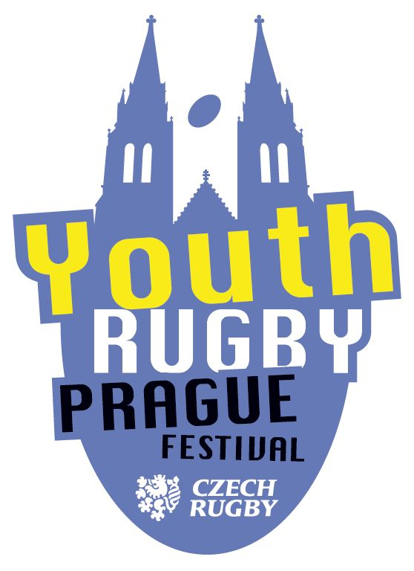 | PRAGUE YOUTH RUGBY FESTIVAL 2025  TECHNICAL DETAILS  autumn edition October 18, 2025

Tournament Organizer: RC Tatra Smíchov

Main organizer:
deputy Iva Riegertová, tel. + 420 731 126 095, email: ivariegert1@gmail.com

Date and place: Saturday, October 18, 2025, upper pitch Strahov
Address of the grounds: Běžecká street, Praha 6, map
Bus parking: 100m / 1 min walk from the grounds.

Teams:
There are 26 teams registered (24 Czech and 2 German)
Foreign teams: Heidelberg A/B
Domestic teams: RC Tatra Smíchov, RK Petrovice, RC Praga, Rugby Babice, RCM Říčany, RA Olymp Praha, RC Bystrc, Dragon Brno, RA Brno, RC Slavia Praha,
Rugby Club Havířov, RC Sparta Praha, RC Kralupy, ARC Iuridica,
RC JIMI Vyškov, Vlci&Vlčice Úžice, Strong girls&boys, RC Plzeň

Terms:
Players born in the period from 1. 1. 2016 to 31. 12. 2017. Foreign teams send team roosters in the format specified by the organizer (for each team separately). Signed lists to be handed over upon arrival at a tournament at registration to check. Presentation of valid travel documents / ID cards may be required. CZ: Kluby z Česka provedou registraci soupisek před turnajem v systému ČSRU a přivezou vytištěný a zástupcem klubu podepsaný seznam hráčů s číslem licence a datem narození pro každý svůj tým ke kontrole organizátorem před startem turnaje.

Program:
- 9.00 opening the grounds
- 9.30 coaches meeting in the clubhouse
- 9.50 opening ceremony
- 10.00 kickoff of the first game
- 12:00 -13:00 lunch
- 13:10 kick-off of afternoon section
- 15:00 final matches
- 15.30 final ceremony and results presentation

System of play:

First round - group stage, round robin system.
Group A with six teams, groups B-E with five teams.
Playing time 1x7 minutes (1x6 minutes in group A).
Teams will be seeded into first round groups by serpentine system based on last PYRF edition ranking. Při nasazení jsme přihlédli i k výsledku ORF v Olomouci (dominantní Bystrc) a kombinovali jeho výsledek s posledním PYRFem. Pořadí od třetích pozic v základních skupinách jsme pak měnili i tak, aby spolu nehrály A a B z jednoho klubu, aby se co nejvíce potkaly české oddíly s moravskými a aby měly vzájemný zápas Amazonky a Vlčice.

Second round - group stage, round robin system.
Teams from 1st and 2nd place from first round will play in semifinal groups and will be seeded:
group G: 1A, 2B, 1C, 2D, 1E and group H: 2A, 1B, 2C, 1D, 2E
Teams from 3rd place from first round will play in classification group 11-15
Teams from 4th place from first round will play in classification group 16-20
Teams from 5th place (and team 6A) from first round will play in classification group 21-26, the result 5A-6A will be taken from their first round group A.
Playing time 1x7 minutes (1x6 minutes in group 21-26).

Final classification matches round - for teams from SF groups G/H only.
Match for 9th place - 5G vs. 5H
Match for 7th place - 4G vs. 4H
Match for 5th place - 3G vs. 3H
Match for 3rd place - 2G vs. 2H
Final match - 1G vs. 1H
Playing time 1x7 minutes

The criteria for first and second round group ranking:
1. Number of points.
Win = 3 points, draw = 2 points, loss = 1 point, loss by forfeit: score 5:0 and 3 points is awarded to the present team, score 0:5 and 0 points is awarded to the absent team
2. Score difference
3. Bigger number of tries
4. Head-to-head result in that group
5. Better disciplinary record, less red/yellow-carded players in the tournament
6. Higher number of players born in 2017 registered for the tournament
7. Head-to-head from previous phase (mutual match from the first round as a criteria for second round group ranking).
8. Coin toss

Tie in final classification matches
If the final classification match results in a tie, it will be followed by 2 minutes break and an extra-time for 3 minutes with "golden try" as the team scoring first wins the match. If there is no try in extra-time, the match continues with only five against five players until the decision as the first scoring team wins the match.

Rules
Pitch size: 21,5 m x 40 m, no “22m” line
Ball size: 3
Team numbers: 6-a-side
Rolling substitutions are permitted and substituted players can be re-used at any time.
Hand-off: Not allowed
Charging: Not allowed
Tackle: Around waist or below / below armpits.
No targeting the ball before the tackle is completed.
Ruck: Max 1+1 v 1+1
Maul: Max 2 v 2
Kicking: Drop kick is used to start the match and to restart after scoring. Players are allowed to kick, BUT if the ball goes to touch or touch-in-goal or to the dead ball line, a free kick is awarded to the non-offending side at the place of the kick.
Scrums: Tap
Line outs: Tap
Free kick: Tap
Opposition: Distance at least 8 meters
Duration: 7 min / 6 min

Exclusion: If a player is temporarily suspended from a play (verbally or by issuing a yellow card), he may be substituted (the number of players remains six) and must not participate in the match for at least 90 seconds.
If a player is permanently suspended from a match (verbally or by issuing a red card), he may be substituted (the number of players remains six) and must not participate in the match until the end of the match.
The tournament management will decide on any further punishment for a permanently suspended player (ban from playing in a certain number of matches or until the end of the tournament).
Refs will issue a temporary or permanent suspension for rule violations that jeopardize player safety.

