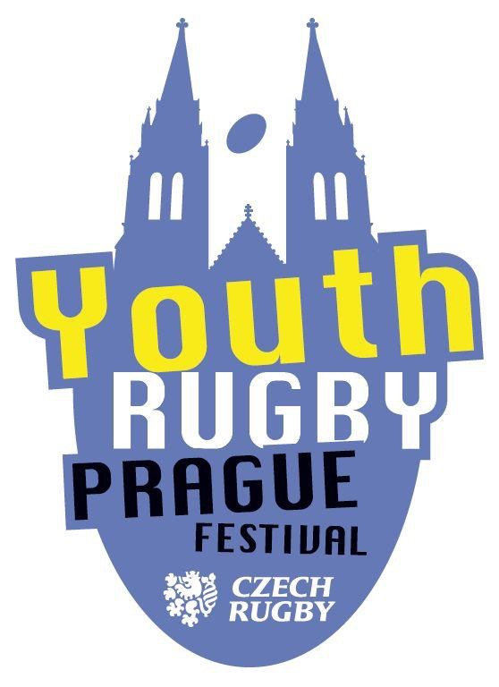 | P R A G U E Y O U T H  R U G B Y F E S T I V A L  U12

XXXIV. PICO CUP / PYRF U12

Tournament Schedule
Tournament Organizer: Rugby Club Petrovice in cooperation with the Prague Youth Rugby Festival
Main Organizer: Jana Stupková
Phone: +420 607 877 793
E-mail: jastupkova@gmail.com
Date and Venue of the Tournament:
Saturday, October 18, 2025
Venue: RK Petrovice Stadium, Grammova 408/6, 109 00 Prague 10

Registered Teams
(in order of registration)
Zagrebački Ragbi Savez (CRO), ACS Warriors Timisoara (ROM), RG Heidelberg I (GER), RG Heidelberg II (GER), Ragby Olymp, Rugby Babice, RC Tatra Smíchov I, RC Tatra Smíchov II, RC Olomouc, RC Sparta Praha, RC Praga Praha I, RC Praga Praha II, ARC Iuridica, JIMI RC Vyškov, RK Petrovice I, RK Petrovice II, RC Mountfield Říčany I, RC Mountfield Říčany II, TJ Sokol Mariánské Hory, RC Dragon Brno, AMMOR, RC Slavia Praha, RC Bystrc, RC Havířov, RA Brno.

Participation Conditions
Both boys and girls born between January 1, 2014 and December 31, 2015 (inclusive) are eligible to play.
Players from teams affiliated with the Czech Rugby Union (ČSRU) must have a valid ČSRU player license as of the tournament date.
Team managers of foreign teams must fill in List of players form and send in advance + originals bring for the coaches meeting on match day.
The same printed roster, signed by the head coach or team manager, must be submitted to the main organizer before the start of the tournament.
Club affiliation of players will not be checked. Each team must have its own separate roster.

Tournament Schedule (subject to change; final version will be confirmed after registration closes)
08:00 – Venue opens
09:00–09:30 – Team check-in, submission of signed rosters
09:30 – Coaches’ meeting near the clubhouse
09:40 – Kick-off of first matches
09:40–13:00 – Qualifying group matches
13:00–14:00 – Lunch
14:00–16:30 – Final group matches
16:45 – Awards ceremony and official closing of the tournament

Tournament Format
The tournament is competitive.

Preliminary Round:
Five qualifying groups with five teams each.
Each team plays every other team in its group once.
Group A plays on Field A
Group B plays on Field B
Group C plays on Field C
Groups D and E alternate between fields according to the schedule.
Teams in groups D and E are asked to be ready on time at the assigned fields.

Final Round:
Again, five groups of five teams.
CUP group: winners of all qualifying groups (places 1–5 overall)
PLATE group: teams finishing 2nd in qualifying groups (places 6–10 overall)
BOWL group: teams finishing 3rd (places 11–15 overall)
SHIELD group: teams finishing 4th (places 16–20 overall)
Group 21–25: teams finishing 5th (places 21–25 overall)
No additional finals or playoffs are played — final rankings are determined by standings within each group.
CUP group plays on Field A
PLATE group on Field B
BOWL group on Field C
SHIELD and Group 21–25 alternate across all fields.
Again, please ensure teams from SHIELD and Group 21–25 are ready on time for their matches.

Match Scoring

Win: 3 points
Draw: 2 points
Loss: 1 point
If a team fails to appear for a match:
The present team is awarded a 5:0 win and 3 points
The absent team records a 0:5 loss and 0 points
In the case of equal points within a group, the ranking is determined in this order:
a) Higher difference between tries scored and conceded (lower negative value if applicable)
b) If equal, then higher number of tries scored
c) If still equal, result of the head-to-head match
d) If still equal, fewer players sent off during the tournament
e) If still equal, higher number of younger players (born 2015) listed on the roster
f) If still equal, drawing of lots
Rules
According to “Modified Rugby Rules for Youth and Juniors – August 2024,” issued 12 August 2024, category U12 Autumn, with scrums and lineouts.
Referees
Head Referee: Raymond Burnard (Class II referee)
Other referees: Class III and MINI rugby referees from OPČ region clubs
Technical and Organizational Notes
Moravian teams will have locker rooms in the clubhouse.
Teams from the OPČ region will have tents available.
Teams may also bring their own tents to set up above or behind Field C.
Parking:
Entry into Grammova Street will be prohibited except for deliveries
(note: transporting players is not considered delivery!).
Please use nearby parking lots:
At MHD Newtonova stop
In Morseova Street (above the Sokolovna)
In Dopplerova Street (between schools – suitable for buses)
All these parking areas are free of charge.
Lunches can be ordered from Mr. Václav Prokeš,
Lunches for foreign teams are organized and ask for lunch tickets on Coaches meeting
Access to the playing fields is restricted to referees, players, coaches, scorekeepers, and organizers only.
Please remind parents to watch matches from the stands or surrounding areas.
Best regards,
Rugby greetings!
Oto Petrášek – member of the organizing committee PYRF / PICO CUP U12 – Autumn 2025

PICO CUP TOURNAMENT WINNERS – OVERVIEW
Year | Winner
I. 1991 | RC Tatra Smíchov
II. 1992 | Results unavailable
III. 1993 | Results unavailable
IV. 1994 | RC Vyškov
V. 1995 | RK Petrovice
VI. 1996 | RK Petrovice
VII. 1997 | RC Slavia Praha
VIII. 1998 | Results unavailable
IX. 1999 | Results unavailable
X. 2000 | Results unavailable
XI. 2001 | Results unavailable
XII. 2002 | Results unavailable
XIII. 2003 | Results unavailable
XIV. 2004 | Results unavailable
XV. 2005 | RC Říčany
XVI. 2006 | JIMI RC Vyškov
XVII. 2007 | JIMI RC Vyškov
XVIII. 2008 | RC Tatra Smíchov
XIX. 2009 | RC Sparta Praha
XX. 2010 | RC Říčany
XXI. 2011 | RC Říčany
XXII. 2012 | RC Říčany B
XXIII. 2013 | RC Říčany B
XXIV. 2014 | RC Říčany A
XXV. 2015 | RC Říčany
XXVI. 2016 | RC Mountfield Říčany A
XXVII. 2017 | RC Mountfield Říčany A
XXVIII. 2018 | RC Tatra Smíchov A
XXIX. 2019 | RK Petrovice
2020 | Tournament not held (COVID-19 pandemic)
XXX. 2021 | RC Mountfield Říčany
XXXI. 2022 | RC Tatra Smíchov I
XXXII. 2023 | RC Mountfield Říčany I
XXXIII. 2024 | RC Mountfield Říčany A
XXXIV. 2025 | ?????

